Functional Specification
Version [1.0.0]

SHP – UPLOAD TRANSACTION SAMPLE DAN GIMMICK

Prepared By
RUMANTININGTYAS
PT SANGHIANG PERKASA

Date
[18/05/2020]
Revision history
Version | Date |  | Author(s) | Description
1.0.0 | 18 MAY 2020 |  | Rumantininggtyas | No Previous Document
Document Approval
Full name |  | Job Title |  |  | Signature | Signature Date

User Interface

[New] UPLOAD CASH RECEIPT

File Upload

Design
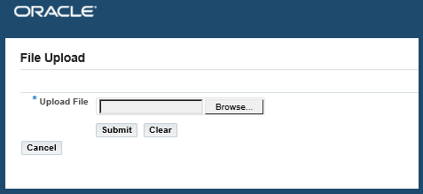

Field Description
Field Name | Description | Mandatory | Type | Data Type | Notes
Upload File | Upload file received from customer | Y | Browse |  | File akan diupload oleh user FA

Action Control
Control Name | Description | Action | Type | Validation | Result
Submit | Untuk submit file | On Click | Button |  | Submit file yang akan dinaikan ke table staging sebelum masuk ke Oracle
Clear | Untuk clear field browse | On Click | Button |  | Clear field browse file, sehingga bisa mencari file baru
Cancel | Membatalkan file | On Clict | Button |  | Membatalkan file yang sudah dibrowse sebelumnya

[New] VALIDASI CASH RECEIPT

VALIDASI CASH RECEIPT

Design
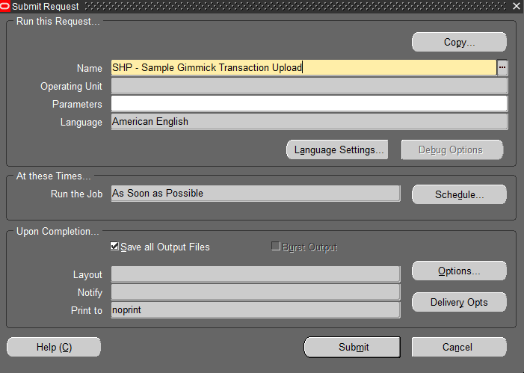
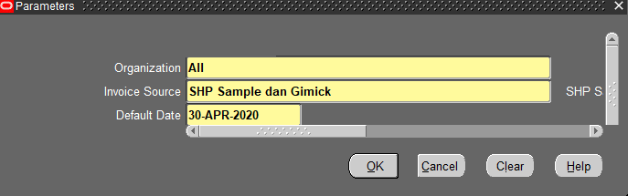

Field Description
Field Name | Description | Mandatory | Type | Data Type | Notes
Concurrent Name | Pilih SHP – Sample Gimmick Transaction Upload | Y | LOV | Text
Parameter
Organization | Organization Unit transaction akan terbentuk | Y | LOV | Text | Default All
Invoice Source | Source Invoice  RA_BATCH_SOURCES_ALL | Y | LOV | Text | Default SHP Sample dan Gimick
Default Date | Tanggal Transaction | Y | LOV | Date | Default Blank

Appendix

